A) B)
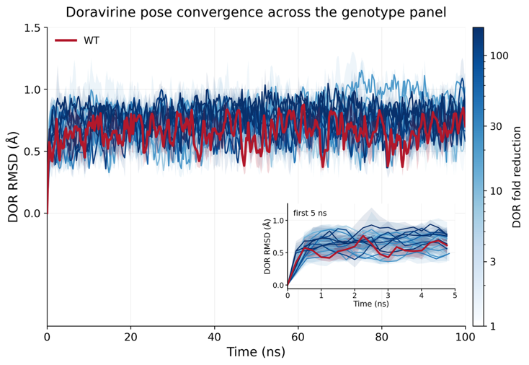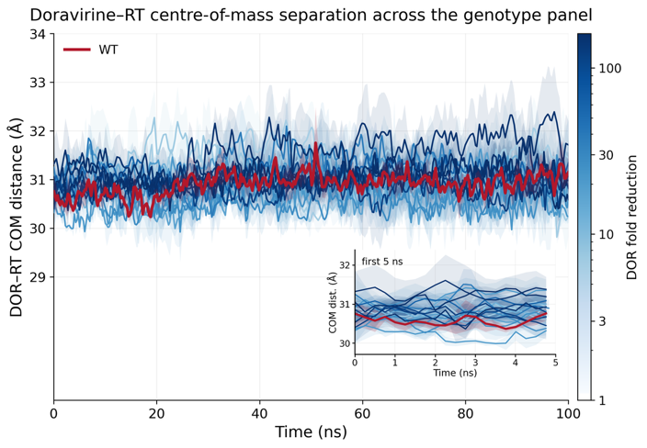
Supplementary Figure 1. DOR Root Mean Squared Deviation (RMSD) and distance between centers of mass (COM) of DOR and RT indicate 100ns runtime is sufficient for DOR-RT interactions to stabilize.
(A) Each solid line provides the average RMSD of the DOR heavy atoms vs the minimized structure within the NNIBP (at t = 0) computed at each time point across triplicate simulations. Shaded regions represent the standard error this mean (SEM). The red curve represents WT and the remaining trajectories are color-coded based on the respective genotype’s fold-change in susceptibility (Table 1 in main text). Inset shows the same data highlighting the rapid changes in the first 5ns of the simulations. (B) Similar plot for the average distance between the centers of mass (COM) of DOR and RT atoms.

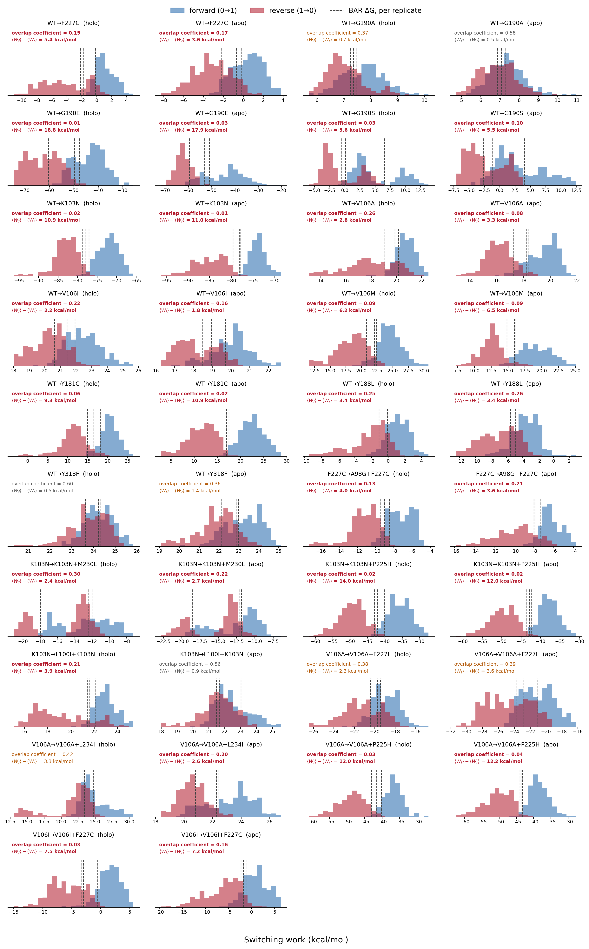
Supplementary Figure 2. Non-equilibrium switching work distributions for all alchemical legs.
Forward (0→1, blue) and reverse (1→0, red) switching work for each of the 19 alchemical legs, shown separately for the holo and apo phases and pooled across three independent replicates (100 switches per direction per replicate). Dashed lines mark the BAR free energy, ∆G, of each replicate. Each panel reports the forward/reverse overlap coefficient — the shared area under the two normalized work densities, where 0 is disjoint and 1 identical — and the hysteresis ⟨W_{f}⟩ − ⟨W_{r}⟩, which measures the work dissipated by switching at finite speed. Annotations are colored red below an overlap of 0.3 and amber below 0.5. Compound genotypes are reached by two sequential legs, both shown.

